**Datasheet for 144 pins FPGA board PCB**

**EVD17I009**

**EVD17I014**

**ESD17I012**

**EVD17I020**

**ESD17I009**

**List of Contents:**

1. **FPGA core IC** 
   1. **Pin diagram**
   2. **Pin details**
2. **DAC**
   1. **Pin diagram**
   2. **Pin details**
3. **ADC** 
   1. **Pin diagram**
   2. **Pin details**
4. **Keypad** 
   1. **Pin diagram**
   2. **Pin details**
5. **LCD** 
   1. **Pin diagram**
   2. **Pin details**
6. **USB (Type A and Type B)**
   1. **Pin diagram**
   2. **Pin details**
7. **Power Supply** 
   1. **Pin diagram**
   2. **Pin details**
8. **LEDs and Switches** 
   1. **Pin diagram**
   2. **Pin details**
9. **Miscellaneous Components**
   1. **Resistors**
   2. **Capacitors**
   3. **Inductors**
   4. **Keypad**
   5. **Vga port**
   6. **Usb port A**
   7. **Usb port B**
   8. **Power supply port**

**1.Fpga core IC**

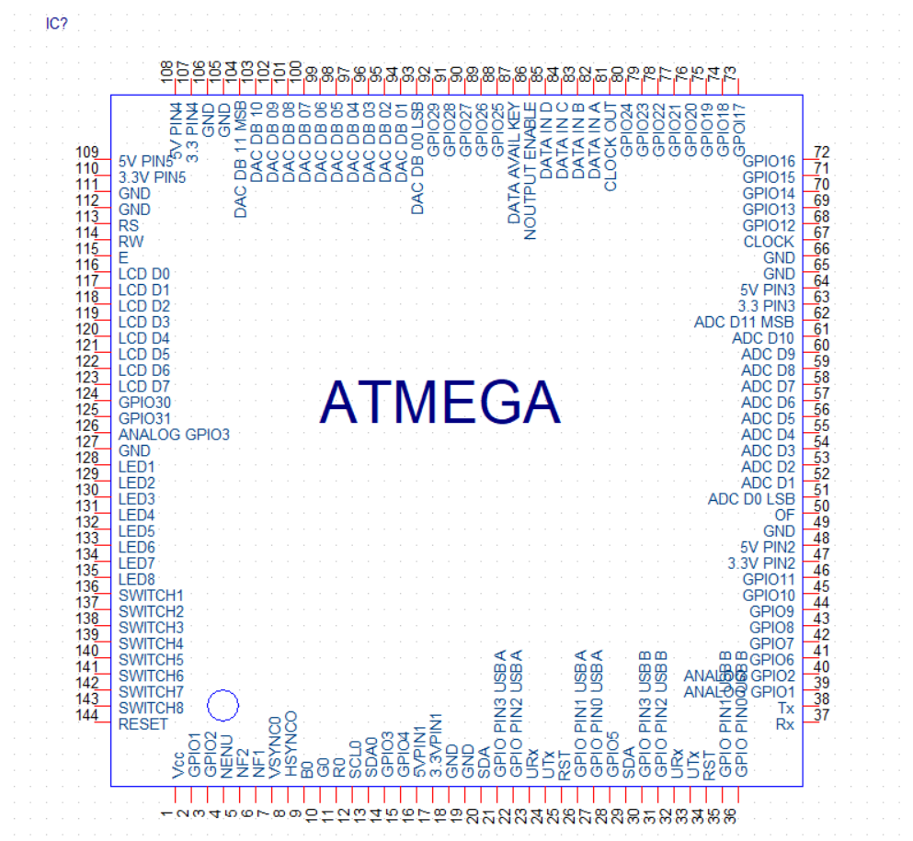

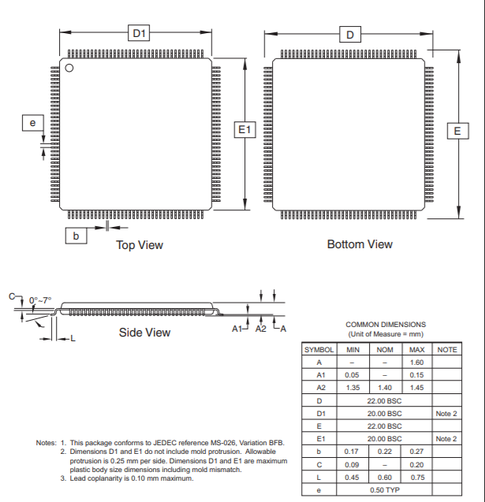

|  |  |  |
| --- | --- | --- |
| **Pin no** | **Name** | **Function** |
| **1** | **Vcc** | Supply voltage 3.3v |
| **2** | **GP i/o 1/GND** | General purpose input output, also dedicated to ic ground |
| **3** | **GP i/o 2** | General purpose input output |
| **4** | **NENU()** | USB Enable Input. Drive ENU low to enable the USB power-supply outputs.(Active Low) |
| **5** | **NF2()** | Fault Output 2. F2 is an active-low, open-drain output that asserts when a fault condition is detected on USB2 |
| **6** | **NF1()** | Fault Output 1. F1 is an active-low, open-drain output that asserts when a fault condition is detected on USB1 |
| **7** | **VSYNC0** | Vertical Sync Input |
| **8** | **HSYNC0** | Horizontal Sync Input |
| **9** | **B0** | RGB Analog Input |
| **10** | **G0** | RGB Analog Input |
| **11** | **R0** | RGB Analog Input |
| **12** | **SCL0** | DDC(digital down converter) Input/Output |
| **13** | **SDA0** | DDC(digital down converter) Input/Output |
| **14** | **GP I/O 3** | General purpose input output |
| **15** | **GP I/O 4** | General purpose input output |
| **16** | **5V Pin 1** | 5V output |
| **17** | **3.3V Pin 1** | 3.3V output |
| **18** | **GND** | Dedicated Ground Pin |
| **19** | **GND** | Dedicated Ground Pin |
| **20** | **SDA** | I^2C Data line |
| **21** | **GP i/o Pin 3 USB A** | General-purpose I/O or alternate  function pin |
| **22** | **GP i/o Pin 2 USB A** | General-purpose I/O or alternate  function pin |
| **23** | **URx** | UART RX pin (input) |
| **24** | **UTx** | UART TX pin (Output) |
| **25** | **RST** | reset |
| **26** | **GP i/o Pin 1 USB A** | General-purpose I/O or alternate  function pin |
| **27** | **GP i/o Pin 0 USB A** | General-purpose I/O or alternate  function pin |
| **28** | **GP I/O 5/Not Connected** | General purpose input output/ not connected |
| **29** | **SDA** | I^2C Data line |
| **30** | **GP i/o Pin 3 USB A** | General-purpose I/O or alternate  function pin |
| **31** | **GP i/o Pin 2 USB A** | General-purpose I/O or alternate  function pin |
| **32** | **URx** | UART RX pin (input) |
| **33** | **UTx** | UART TX pin (Output) |
| **34** | **RST** | General purpose input output |
| **35** | **GP i/o Pin 1 USB A** | General-purpose I/O or alternate  function pin |
| **36** | **GP i/o Pin 0 USB A** | General-purpose I/O or alternate  function pin |
| **37** | **Rx** | Serial receiver |
| **38** | **Tx** | Serial transmitter |
| **39** | **Analog GP i/o 1** | Analog General purpose input output |
| **40** | **Analog GP i/o 2** | Analog General purpose input output |
| **41** | **GP I/O 6** | General purpose input output |
| **42** | **GP I/O 7** | General purpose input output |
| **43** | **GP I/O 8** | General purpose input output |
| **44** | **GP I/O 9** | General purpose input output |
| **45** | **GP I/O 10** | General purpose input output |
| **46** | **GP I/O 11** | General purpose input output |
| **47** | **3.3V Pin2** | 3.3V output |
| **48** | **5V Pin2** | 5V output |
| **49** | **GND** | Dedicated Ground Pin |
| **50** | **OF** | Overflow Output. This signal is high when the  digital output is 011111111111 or 100000000000. |
| **51** | **ADC D0 LSB** | Data Outputs. The output format  is two’s complement. |
| **52** | **ADC D1** | Data Outputs. The output format  is two’s complement. |
| **53** | **ADC D2** | Data Outputs. The output format  is two’s complement. |
| **54** | **ADC D3** | Data Outputs. The output format  is two’s complement. |
| **55** | **ADC D4** | Data Outputs. The output format  is two’s complement. |
| **56** | **ADC D5** | Data Outputs. The output format  is two’s complement. |
| **57** | **ADC D6** | Data Outputs. The output format  is two’s complement. |
| **58** | **ADC D7** | Data Outputs. The output format  is two’s complement. |
| **59** | **ADC D8** | Data Outputs. The output format  is two’s complement. |
| **60** | **ADC D9** | Data Outputs. The output format  is two’s complement. |
| **61** | **ADC D10** | Data Outputs. The output format  is two’s complement. |
| **62** | **ADC D11 MSB** | Data Outputs. The output format  is two’s complement. |
| **63** | **3.3V Pin3** | 3.3V output |
| **64** | **5V Pin3** | 5V output |
| **65** | **GND** | Dedicated Ground Pin |
| **66** | **GND** | Dedicated Ground Pin |
| **67** | **CLOCK** | Crystal oscillator input (upto 50Mhz) |
| **68** | **GP I/O 12** | General purpose input output |
| **69** | **GP I/O 13** | General purpose input output |
| **70** | **GP I/O 14** | General purpose input output |
| **71** | **GP I/O 15** | General purpose input output |
| **72** | **GP I/O 16** | General purpose input output |
| **73** | **GP I/O 17** | General purpose input output |
| **74** | **GP I/O 18** | General purpose input output |
| **75** | **GP I/O 19** | General purpose input output |
| **76** | **GP I/O 20** | General purpose input output |
| **77** | **GP I/O 21** | General purpose input output |
| **78** | **GP I/O 22** | General purpose input output |
| **79** | **GP I/O 23** | General purpose input output |
| **80** | **GP I/O 24** | General purpose input output |
| **81** | **Clock Out** | 50Mhz clock out |
| **82** | **DATA IN A** | Data channel b/w encoder and core ICs |
| **83** | **DATA IN B** | Data channel b/w encoder and core ICs |
| **84** | **DATA IN C** | Data channel b/w encoder and core ICs |
| **85** | **DATA IN D** | Data channel b/w encoder and core ICs |
| **86** | **NOUTPUT ENABLE** | Active low, output enabler for keypad encoder |
| **87** | **DATA AVAIL KEY** | Active high for no data passing(indicates that input is possible) |
| **88** | **GP I/O 25** | General purpose input output |
| **89** | **GP I/O 26** | General purpose input output |
| **90** | **GP I/O 27** | General purpose input output |
| **91** | **GP I/O 28** | General purpose input output |
| **92** | **GP I/O 29** | General purpose input output |
| **93** | **DAC DB 00 LSB** | Digital Output Data Bits. |
| **94** | **DAC DB 01** | Digital Output Data Bits. |
| **95** | **DAC DB 02** | Digital Output Data Bits. |
| **96** | **DAC DB 03** | Digital Output Data Bits. |
| **97** | **DAC DB 04** | Digital Output Data Bits. |
| **98** | **DAC DB 05** | Digital Output Data Bits. |
| **99** | **DAC DB 06** | Digital Output Data Bits. |
| **100** | **DAC DB 07** | Digital Output Data Bits. |
| **101** | **DAC DB 08** | Digital Output Data Bits. |
| **102** | **DAC DB 09** | Digital Output Data Bits. |
| **103** | **DAC DB 10** | Digital Output Data Bits. |
| **104** | **DAC DB 11 MSB** | Digital Output Data Bits. |
| **105** | **GND** | Dedicated Ground Pin |
| **106** | **GND** | Dedicated Ground Pin |
| **107** | **3.3V PIN 4** | 3.3V output |
| **108** | **5V PIN 4** | 5V output |
| **109** | **5V PIN 5** | 5V output |
| **110** | **3.3V PIN 5** | 3.3V output |
| **111** | **GND** | Dedicated Ground Pin |
| **112** | **GND** | Dedicated Ground Pin |
| **113** | **Rs** | Boolean(H/L) H: DATA, L: Instruction code |
| **114** | **Rw** | Boolean(H/L) H: Read (MPU(Module) L: Write (MPU(Module) |
| **115** | **E** | Chip enable signal (Output) |
| **116** | **LCD D0** | Data bit 0 (H/L) |
| **117** | **LCD D1** | Data bit 1 (H/L) |
| **118** | **LCD D2** | Data bit 2 (H/L) |
| **119** | **LCD D3** | Data bit 3 (H/L) |
| **120** | **LCD D4** | Data bit 4 (H/L) |
| **121** | **LCD D5** | Data bit 5 (H/L) |
| **122** | **LCD D6** | Data bit 6 (H/L) |
| **123** | **LCD D7** | Data bit 7 (H/L) |
| **124** | **GP I/O 30** | General purpose input output |
| **125** | **GP I/O 31** | General purpose input output |
| **126** | **Analog GP I/O 3** | Analog General purpose input output |
| **127** | **GND** | Dedicated Ground Pin |
| **128** | **LED 1** | LED in common cathode controlled by active high output pin |
| **129** | **LED 2** | LED in common cathode controlled by active high output pin |
| **130** | **LED 3** | LED in common cathode controlled by active high output pin |
| **131** | **LED 4** | LED in common cathode controlled by active high output pin |
| **132** | **LED 5** | LED in common cathode controlled by active high output pin |
| **133** | **LED 6** | LED in common cathode controlled by active high output pin |
| **134** | **LED 7** | LED in common cathode controlled by active high output pin |
| **135** | **LED 8** | LED in common cathode controlled by active high output pin |
| **136** | **SWITCH 1** | Reads input from active high switch |
| **137** | **SWITCH 2** | Reads input from active high switch |
| **138** | **SWITCH 3** | Reads input from active high switch |
| **139** | **SWITCH 4** | Reads input from active high switch |
| **140** | **SWITCH 5** | Reads input from active high switch |
| **141** | **SWITCH 6** | Reads input from active high switch |
| **142** | **SWITCH 7** | Reads input from active high switch |
| **143** | **SWITCH 8** | Reads input from active high switch |
| **144** | **RESET** | Resets the FPGA |

**2. DAC**

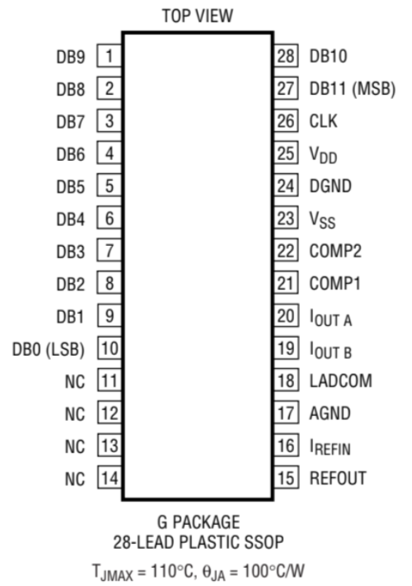

**Pin Functions**

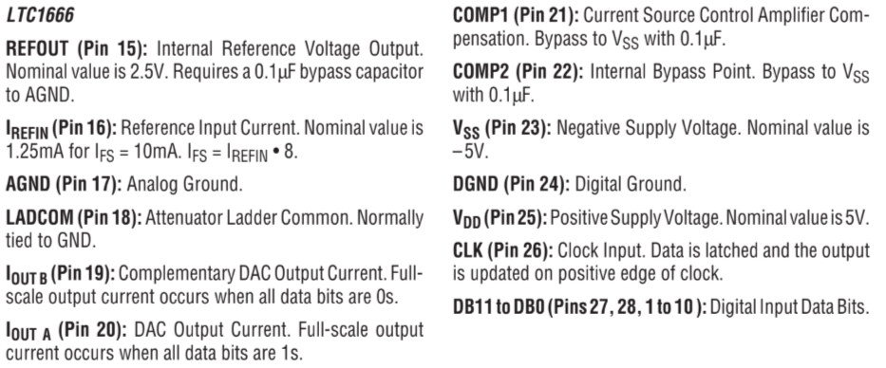

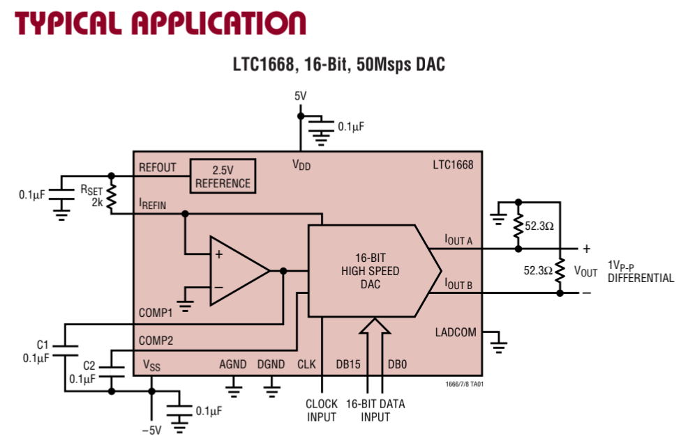

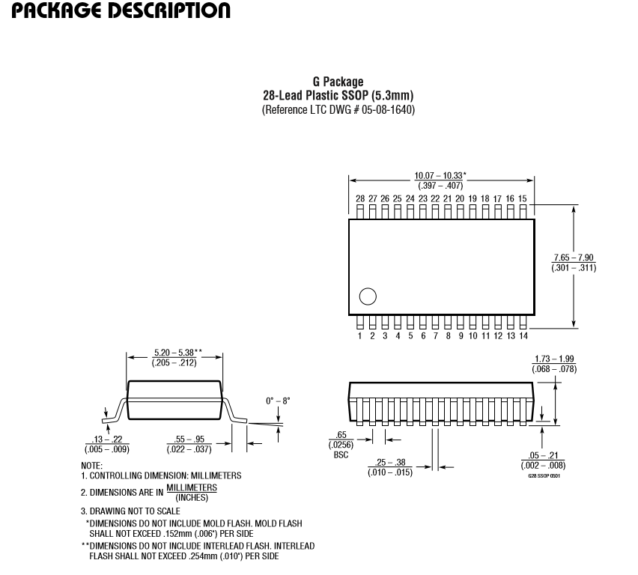

**3.ADC**

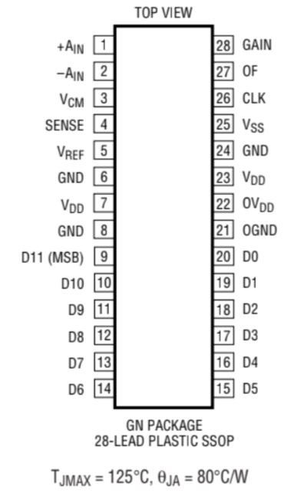

**Pin Functions**

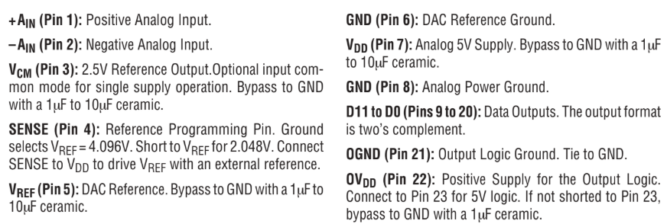

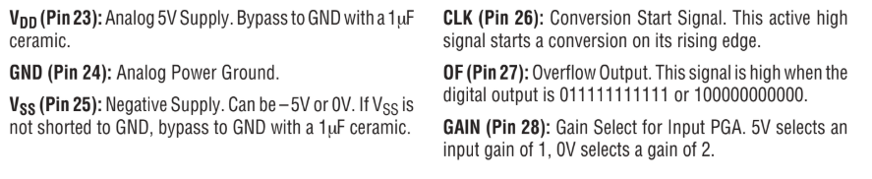

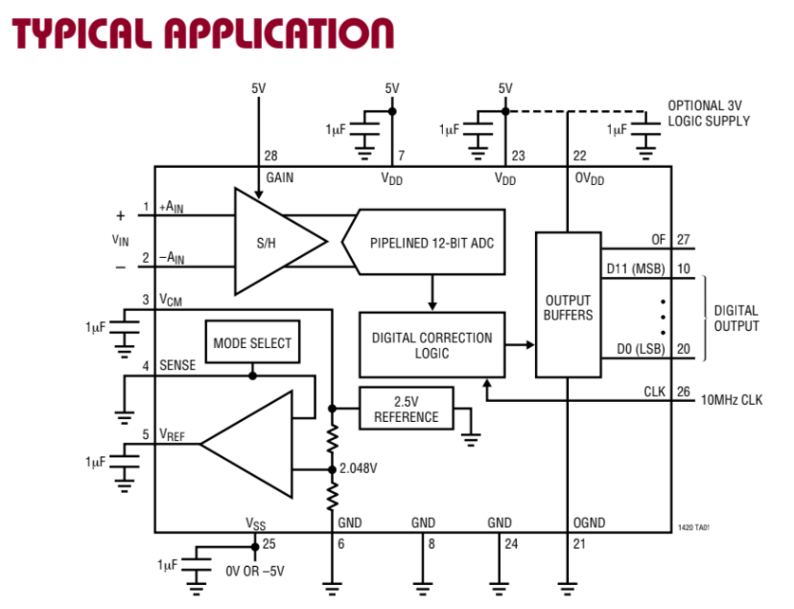

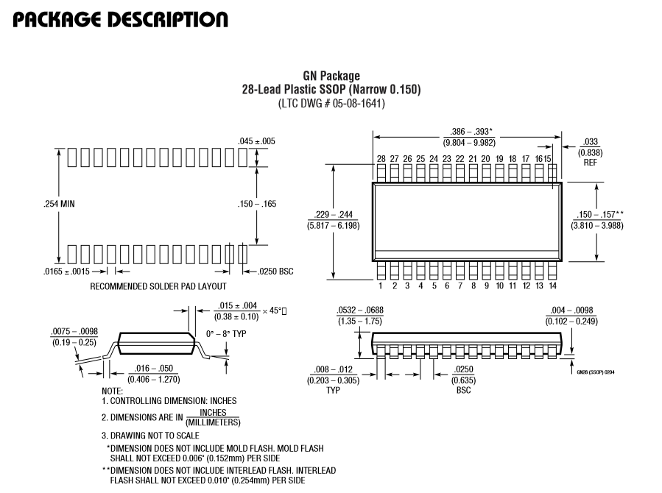

**4.Keypad Encoder**

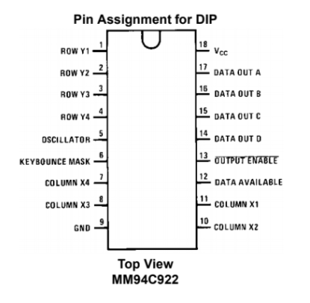

**Pin Functions**

|  |  |
| --- | --- |
| **DATA out A** | Data channel b/w encoder and core ICs |
| **DATA out B** | Data channel b/w encoder and core ICs |
| **DATA out C** | Data channel b/w encoder and core ICs |
| **DATA out D** | Data channel b/w encoder and core ICs |
|  | Active low, output enabler for keypad encoder |
| **DATA AVAIL KEY** | Active high for no data passing (indicates that input is possible) |

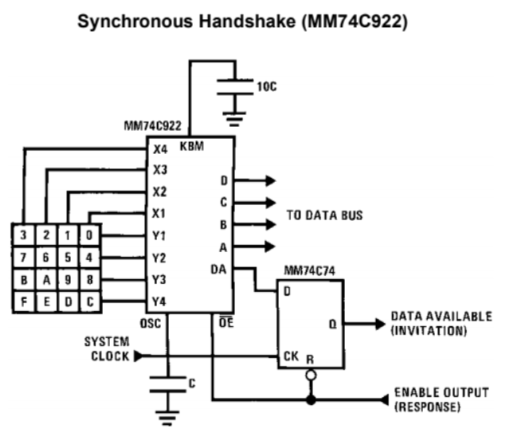

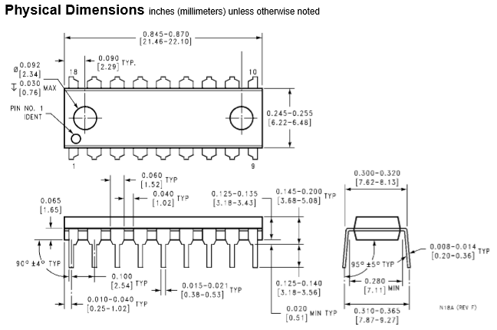

**5. LCD**

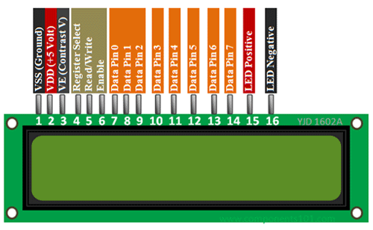

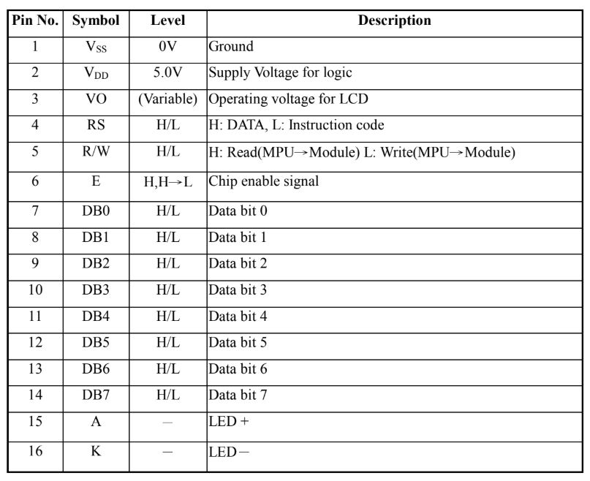

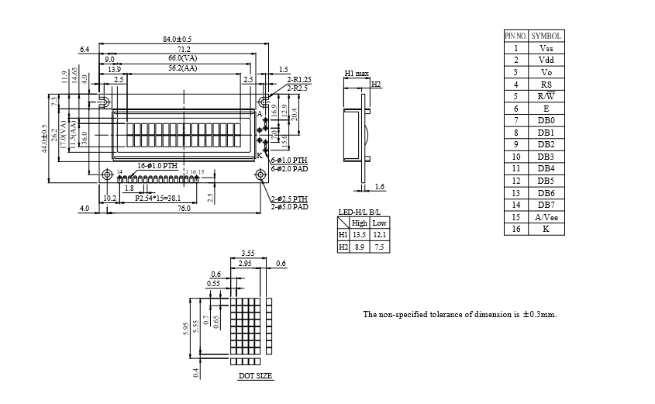

**6.USB (type A and type B)**

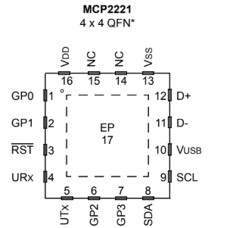

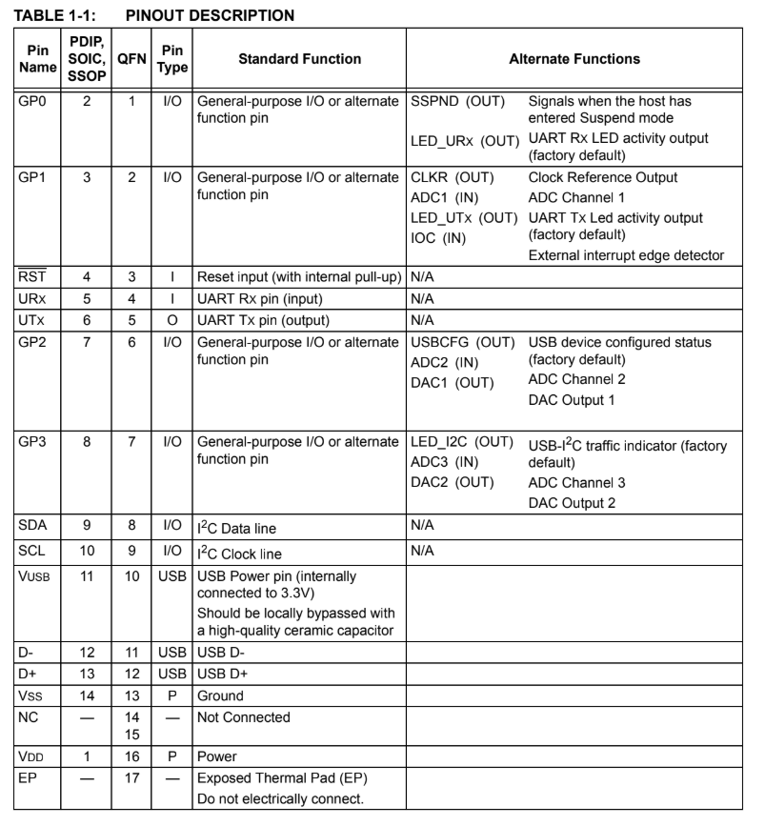

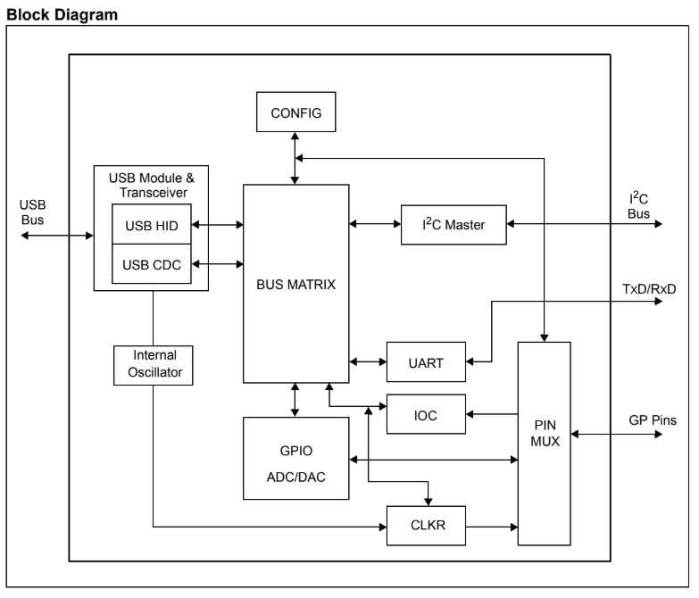

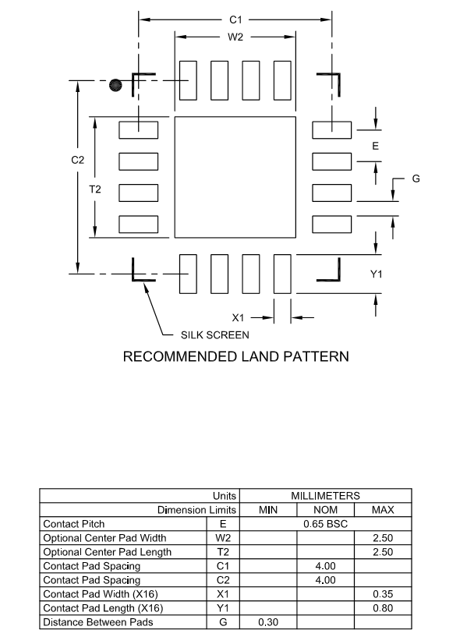

**7.Power Supply**

**a.12V to 5V**

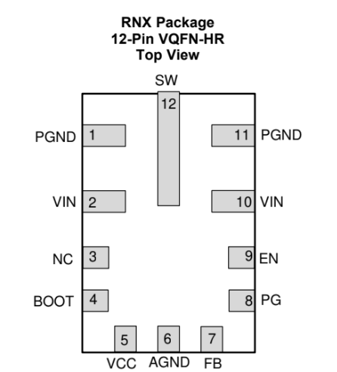

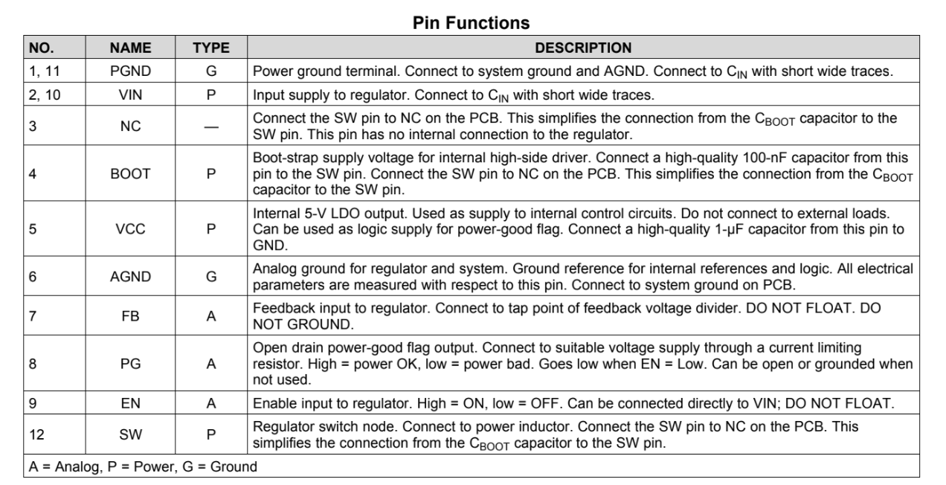

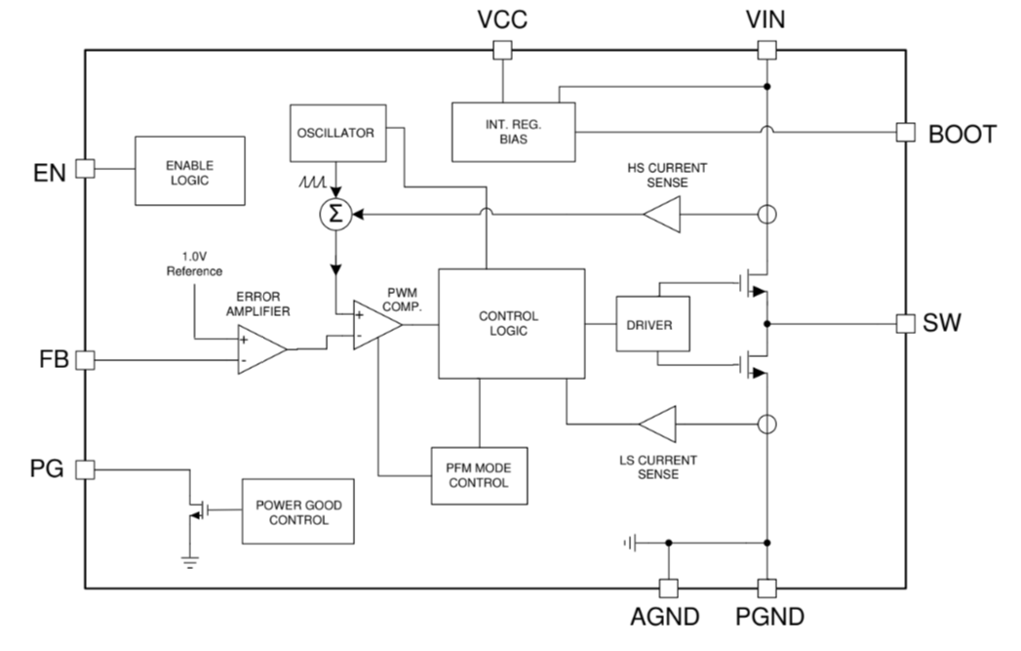

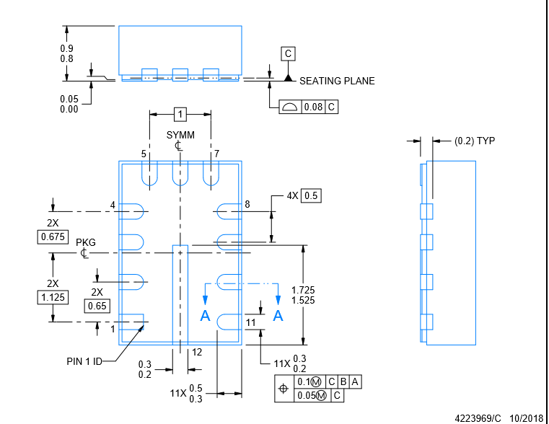

**b.5V to 3.3V**

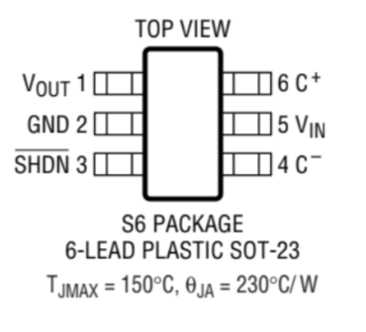

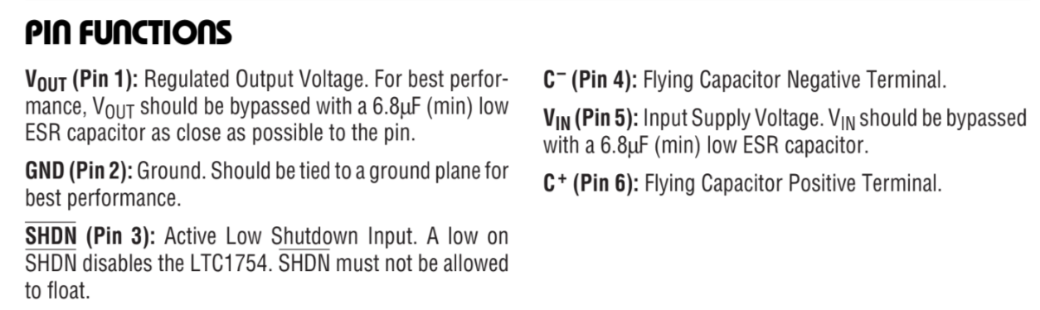

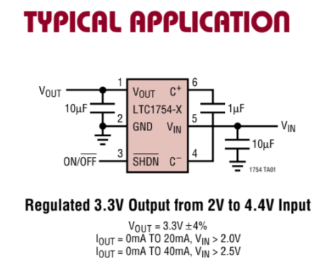

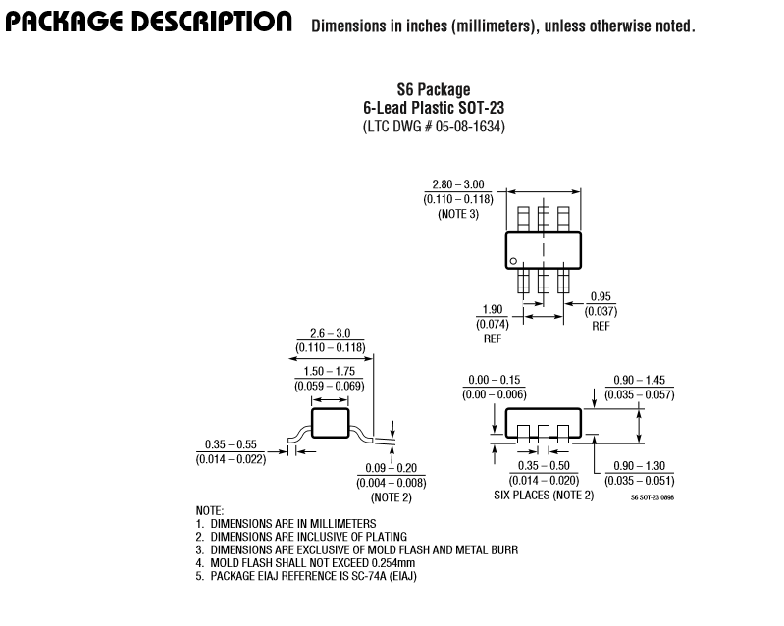

**c.5V to -5V**

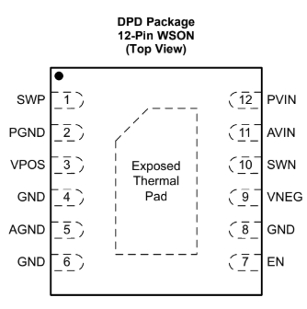

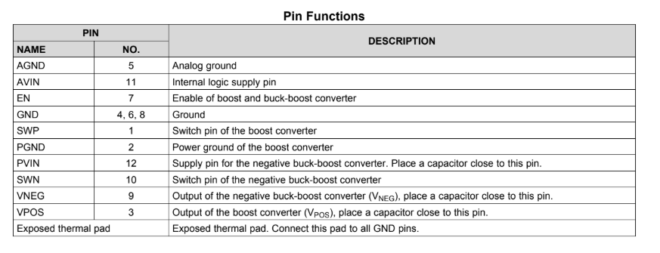

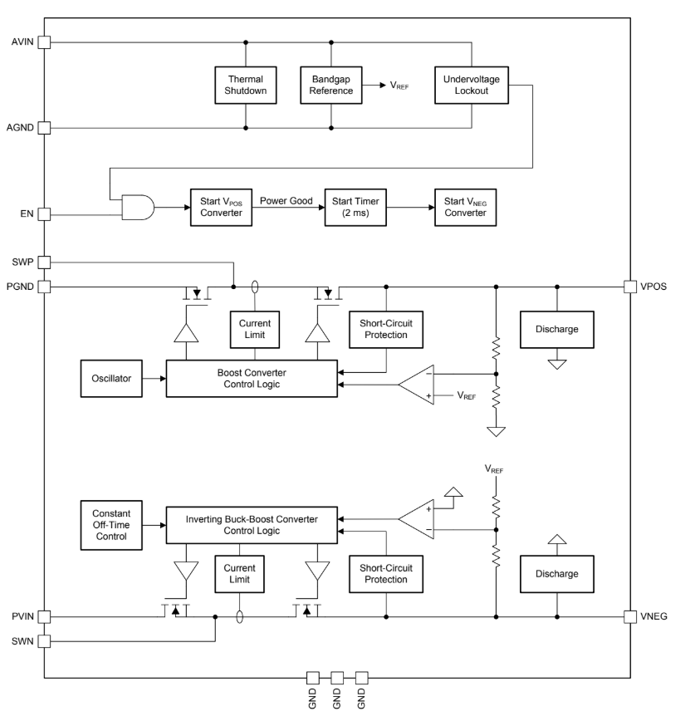

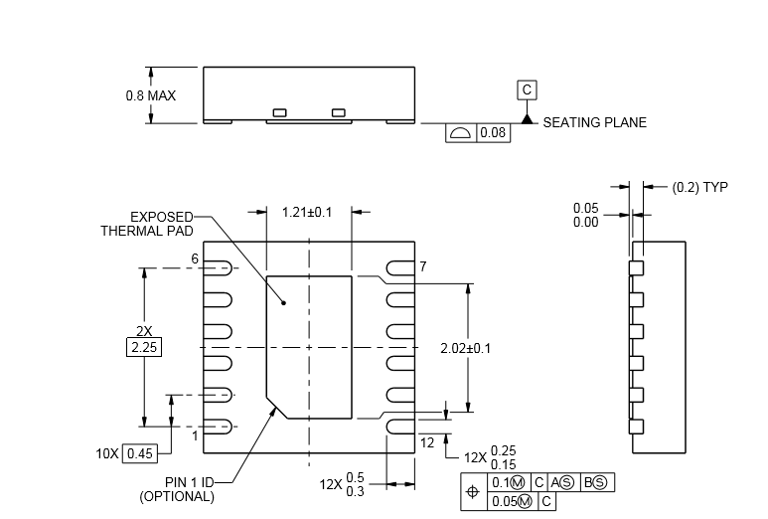

**8. LEDs and Switches**

**a. LED**

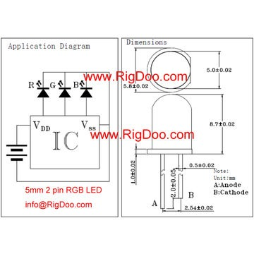

**b.Switch**

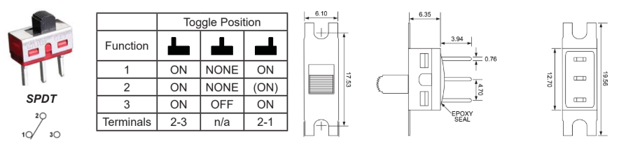

**9.Miscellaneus**

1. **Resistors**

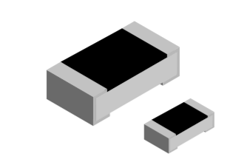

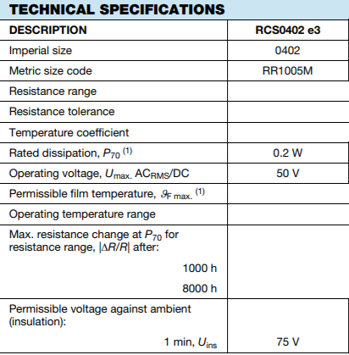

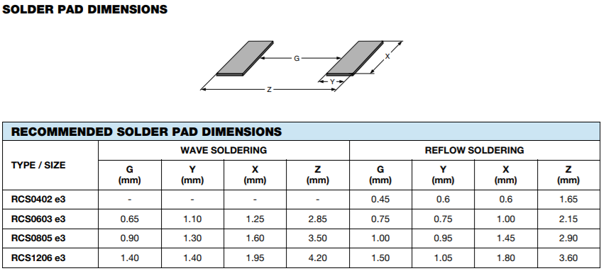

1. **Capacitors**

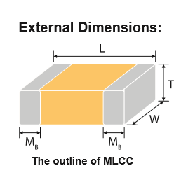

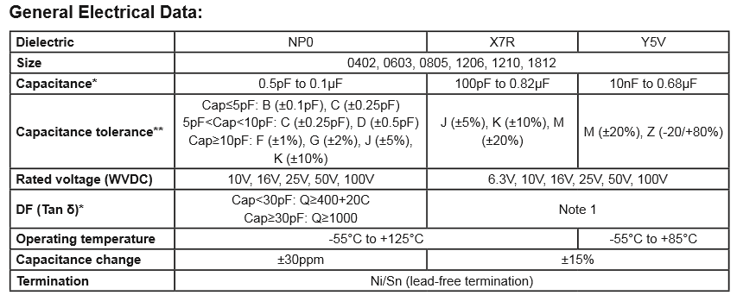

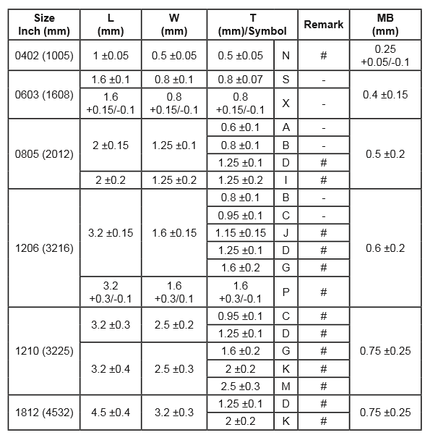

1. **Inductors**



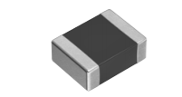

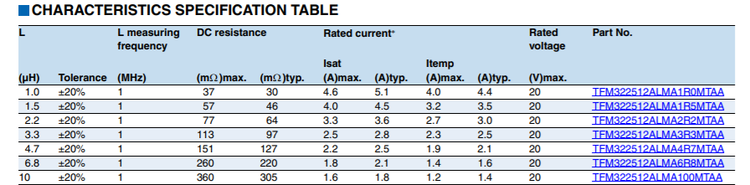

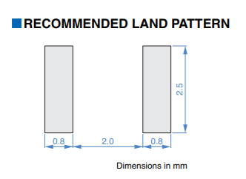

1. **Keypad(switches)**

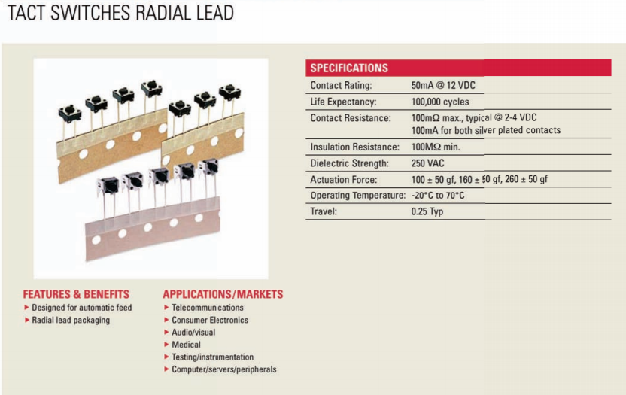

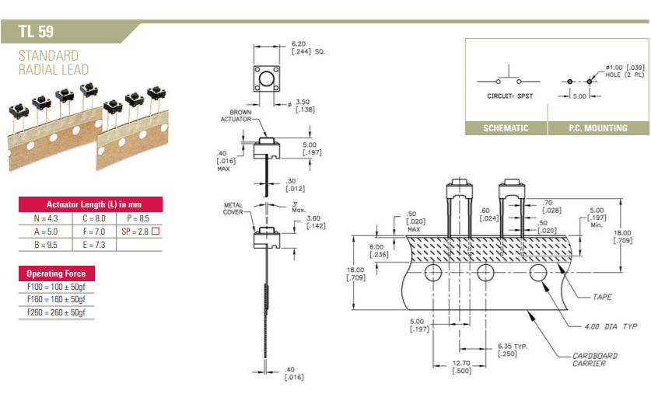

1. **Vga port**

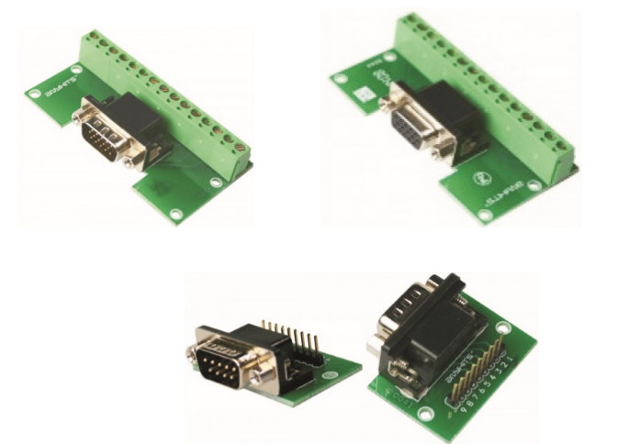

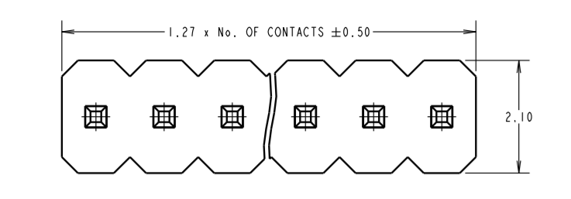

1. **Usb port A**

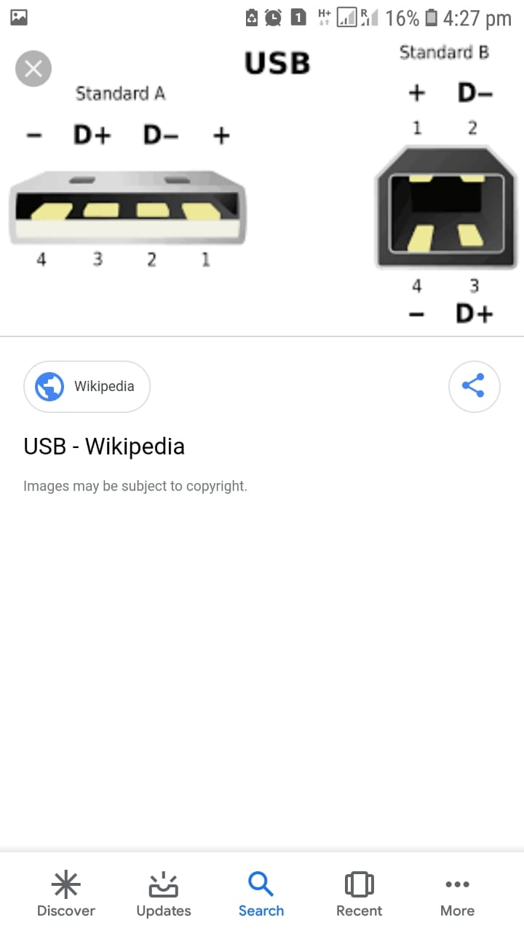

1. **Usb port B**



1. **Power supply port**

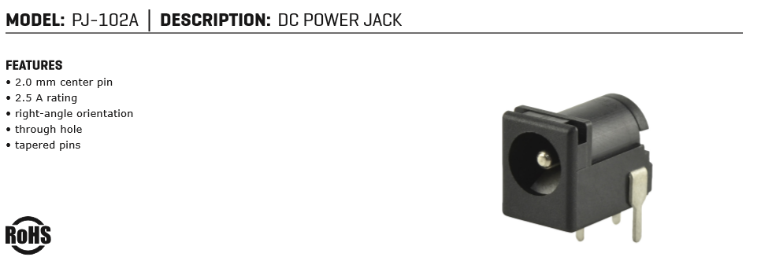

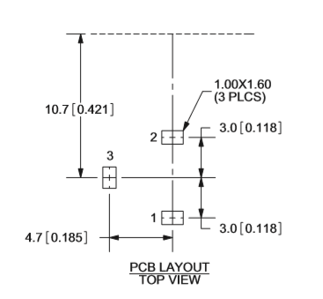

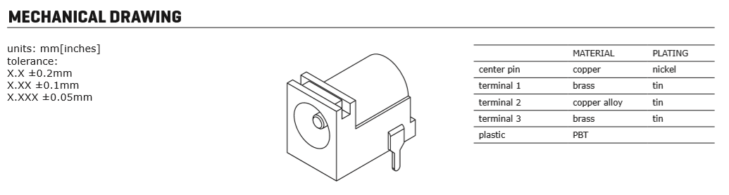

**9.Berg Connector**

